8.42: a) Using Eq. 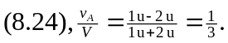 b) The kinetic energy is proportional to the square of the speed, so 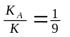c) The magnitude of the speed is reduced by a factor of 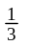after each collision, so after N collisions, the speed is 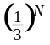of its original value. To find N, consider
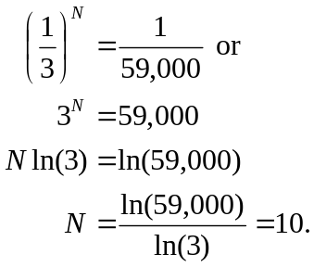
to the nearest integer. Of course, using the logarithm in any base gives the same result.

